Ideation Phase
Brainstorm & Idea Prioritization Template

Date | 08 July 2026
Team ID
Project Name | Sports Hall Booking System
Maximum Marks | 4 Marks

Brainstorm & Idea Prioritization Template:
Brainstorming and Idea Prioritization is the initial stage of the project where different project ideas were explored and analysed based on feasibility, innovation, real-world usefulness, technical complexity, and available resources. Since this project was carried out individually, all brainstorming, analysis, and decision-making activities were performed independently. Various software-based and service-oriented project ideas were evaluated before selecting the most suitable solution. After comparing different concepts, the Sports Hall Booking System using ServiceNow Service Portal was chosen because it addresses a practical problem faced by educational institutions while providing an opportunity to learn ServiceNow development, Service Portal customization, database management, and workflow automation.
Step 1: Individual Brainstorming and Problem Selection
Since this project was developed individually, the brainstorming process involved identifying common problems faced in colleges and educational institutions related to sports facility management. Existing manual booking methods often result in double bookings, poor scheduling, lack of transparency, and inefficient management of sports facilities. Several project ideas were considered and evaluated based on their practical impact and implementation feasibility.
After careful analysis, the Sports Hall Booking System was selected because it provides an efficient digital solution for managing sports hall reservations through an intuitive ServiceNow Service Portal. The project offers real-time booking, slot management, automated booking records, and improved user experience
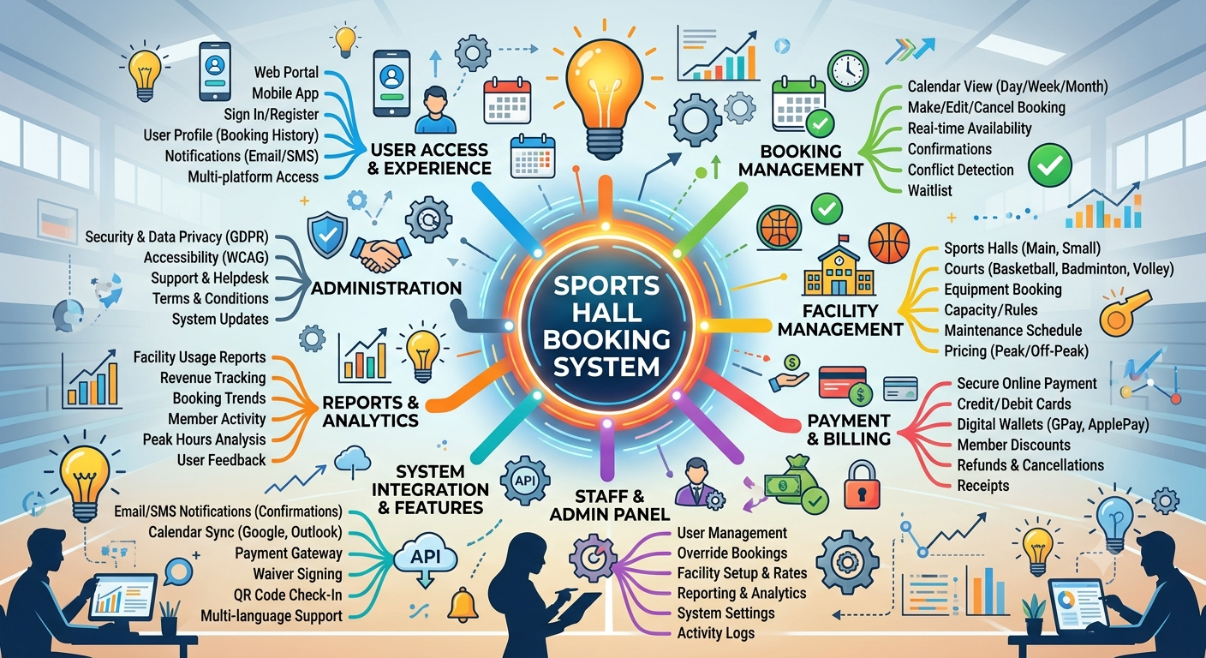

Step-2: Brainstorm, Idea Listing and usability
S.No | Brainstormed Idea | Usability
1 | Online Sports Hall Booking | Enables users to reserve sports halls anytime through the Service Portal.
2 | Real-Time Slot Availability | Displays only available booking slots, preventing scheduling conflicts.
3 | One-Hour Slot Booking | Simplifies booking management with fixed one-hour reservation intervals.
4 | Sport-wise Hall Selection | Allows users to choose the required sports facility easily.
5 | Automatic Booking Charge Display | Instantly displays the booking charge based on the selected sport.
6 | Duplicate Booking Prevention | Prevents multiple users from booking the same hall during the same time slot.
7 | User Booking History | Allows users to view their previous and current bookings.
8 | Booking Confirmation Notification | Confirms successful reservation after booking submission.
9 | Responsive Service Portal Interface | Provides an easy-to-use interface accessible from desktop and mobile devices.
10 | Administrator Booking Management | Enables administrators to monitor and manage all sports hall reservations efficiently.

Step-3: Idea Prioritization
Each shortlisted idea was evaluated using multiple decision criteria. A simple prioritization matrix was prepared to compare the alternatives.
Evaluation Criteria Sports Hall Booking
Innovation ⭐⭐⭐⭐☆
Real-world Impact ⭐⭐⭐⭐⭐
Technical Feasibility ⭐⭐⭐⭐⭐
Learning Opportunity ⭐⭐⭐⭐⭐
Implementation Time ⭐⭐⭐⭐☆
Overall Priority ⭐⭐⭐⭐⭐

